
MASINDE MULIRO UNIVERSITY OF SCIENCE & TECHNOLOGY
MONDAY, MARCH 3, 2025

LAB 01 – 3G & 4G CPE ROUTER
1.0 INTRODUCTION
3G and 4G Customer Premises Equipment (CPE) routers convert broadband or mobile signals into a usable Ethernet and wireless signals, allowing multiple devices to access the internet through their service provider's network as shown in Figure 1. Unlike traditional broadband modems, these routers use a SIM card to connect to cellular networks, making them ideal for homes, offices, and remote locations without reliable wired internet infrastructure.
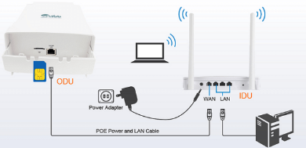
Figure 1. CPE router connections and operation

3G and 4G CPE routers have become a popular alternative to traditional broadband connections, offering the following advantages:
- Easy setup and installation: CPE routers require no professional technology to deploy. Simply insert a SIM card, power on the device, and connect to its network—no professional assistance is required.
- Portability and flexibility: CPE routers provide internet access wherever cellular coverage is available, perfect for on-the-go use or temporary setups.
- Backup internet solution: CPE routers can serve as a failover option during traditional broadband outages, maintaining uninterrupted connectivity.
- Cost-effective solution: For areas where wired broadband installation is costly, CPE routers offers a budget-friendly solution.

EXPERIMENT 1: HUAWEI 3G CPE ROUTER
1. Go to the website: E960 unlocked | HUAWEI E960 Unlocked | HUAWEI E960 Reviews | Buy HUAWEI E960 and write down the following specifications for Huawei E960 3G CPE router.
- Generations of mobile cellular technologies supported
- Uplink and downlink speeds
- Power supply
- Serial communication interfaces
- Data link protocols supported.
- Antennas
- Operating systems supported
2. Connect four laptops and a Plain Old Telephone (POT) to the CPE router.
3. Insert a SIM card in the CPE router
4. Call the telephone number from another phone.
4. Establish data communication to the a news website, a video website and a music website and discuss the performance.

LAB 02 – GPON TERMINAL

INTRODUCTION
Gigabit Passive Optical Network (GPON) is a fiber-optic network technology that provides high-speed internet to homes and businesses. It's a point-to-multipoint network that uses passive splitters to carry a single fiber optic line to multiple end-user connections as shown in Figure 2.
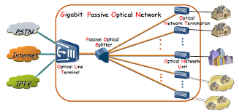
Figure 2. Gigabit Passive Optical Network (GPON)

EXPERIMENT 2 USING HUAWEI GPON HG8145V5 TERMINAL
1. Go to the website: EchoLife EG8145V5 — Huawei Enterprise and write down the following specifications for Huawei E960 3G CPE router.
- Generations of WiFi supported
- Uplink and downlink speeds
- Power supply
- Serial communication interfaces
- Data link protocols supported.
- Antennas
- Operating systems supported
2. Connect four laptops to the GPON terminal and attempt to establish communication. What key link is missing for Internet access?
3. Download the Netspot App onto your phone from Google play

4. Use the WiFi inspector to find the signal strength in dBm for (i) 2.4 GHz band (ii) 5GHz band.
5. Move out of the laboratory and write down the signal strengths again for (i) 2.4 GHz band (ii) 5GHz band.
6. Write down the available channels in the following bands
(i) 2.4 GHz band
(ii) 5GHz band
7. Write down the recommended channels in each band above. Discuss why some channels are recommended and other are left out.

