
MASINDE MULIRO UNIVERSITY OF SCIENCE & TECHNOLOGY
LAB 06 – MOBILE FIELD TEST MODE MONDAY, FEBRUARY 24, 2025
1.0 INTRODUCTION
Field test mode (FTM) ( or field test display (FTD) ) is a software application often pre-installed on mobile phones that provides the user with technical details, statistics relating to the mobile phone network and allows the user to run hardware tests on the phone. On older Nokia phones this mode is known as Netmonitor while newer Series 60 phones have a Field test application which requires a hacked phone to be installed. Many other brands of phones have similar functionality available, often accessed by entering a code into the phone.

EXPERIMENT 1 – ADVANCED MENU TEST

Advanced Test Menu can test most futures on the phone including LCD Display, Touch, LED light, Front and Back Cameras and much more.
1. On the keypad, press *#0*# for phones running Android e.g. Samsung Galaxy ( *3001#12345#* for iPhone xx running iOS 11 or 12 ) to get the display shown below.
2. Press all pads and write down your observations.
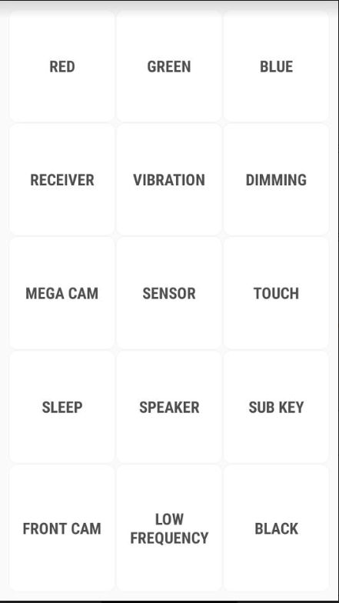

Results and Analysis
1. What are the uses of the tests: Red, Green and Blue.
2. What is it necessary to provide low frequency test but not high frequency test?
3. What are the functions of the sensor tests, i.e accelerometer and the proximity sensor tests?
4. What is being tested when you press the receiver test?

